ADVERTORIAL

Selfless SISTER ACT of Love Saves Sibling’s Life: Sheds 100 Pounds to Donate Kidney



The Miami Health Guardian --- April 2021
By Eileen Honey Strauss

This is a heartwarming story about how one sister lost 100 pounds in two months to save her baby sister’s life.

As little girls, Sydney and Sadie Morrison were inseparable. Even though they were one and a half years apart in age, these sisters acted like twins. They shared their toys, clothes, shoes and jewelry. They also shared a bedroom, a bathroom, and even a car. They had the same friends, joined the same clubs and eventually attended the same college.
Sydney, the younger sister, was a grade behind Sadie, but she tested out of 4th grade and the girls spent the rest of their school age years in the same class. Childhood was fun and the girls vowed to someday buy a house on the same street and raise families together. Nothing would ever keep them apart – at least that was the plan.




As they got older, things started to change. The girls set off to the University of Miami in Coral Gables, Florida in 2008. After only one week in college, Sydney landed a spot on the football team’s cheerleading squad. She spent most of her time with her fellow squad mates and the guys on the football team. As was one of the “beautiful people” on campus Sydney was having the time of her life.
Sydney and Sadie spent a lot of time together during the school day. They ate breakfast together every morning, but because they traveled in different social circles, they started to see each other less and less as time went by. Sadie’s college years were not quite as glamorous as that of her little sister. While Sydney spent her weekends at football games and frat parties, Sadie spent most of her time in the library. A serious 4.0 student, majoring in education, Sadie was laser focused on her studies and her future teaching career.
By graduation in 2012, Sydney and Sadie had each built their own lives and had their own plans. They no longer shared the same friends, interests or dreams for the future. But no matter where life took them, they knew nothing could take away their indestructible relationship and love for each other.
Fast forward to 2017. Sadie had been a teacher in the Fort Lauderdale, FL school district for a while, but was taking some time away from her career to raise her family. She was happily married with had two little girls, savoring a Floridian family life in the sun. Sydney, who had always dreamed of working in the fashion industry, worked for a large Miami-based modeling agency. She was single, active and enjoying all the benefits of the South Beach lifestyle.
Not only were their personal lives drastically different, but they changed physically even more. Sydney, a stay-at-home wife and mother, put on a lot of weight over the years. After the birth of their children, she managed to pack on 100 pounds.
“I didn’t even realize at first how much weight I had gained because I was so busy raising my kids. I tried to lose the weight so many times.” Sadie shared. “I tried Weight Watchers, Atkins, Jenny Craig… you name it, I tried it. Nothing worked. But I didn’t think it was that big of a deal. I knew I would do it eventually and I figured, I’m not hurting anyone by being overweight!”
Or, so she thought.
Sadie, who was living the life of a single girl, maintained her tiny 120 pound frame. The sisters would kid around with each other about how different they were in a way no one else would possibly understand.
“I could make fun of my sister for wearing nothing but sweatpants and t-shirts and she could make fun of my ridiculously overpriced shoes and purses,” Sydney laughed. “We could say whatever we wanted to each other. That’s just how we were.”
No matter how night-and-day the sister’s lives had become, they shared a bond that nothing could break.


But what they didn’t know, was they would soon share much more.

I met Sydney and Sadie two years ago after their story went viral on social media. Sydney was severely injured in an automobile accident and needed a kidney transplant. After hearing about their ordeal, I asked them if I could follow them along their journey. The two sisters agreed.
Sadie and I sat down for an interview and she told me their story.
“In early 2018, Sydney was involved in a very serious car accident which damaged both of her kidneys. She was told she would need a kidney transplant, or she would die.” Sadie revealed. “The doctors told her she was on the transplant list. They said she needed to get a kidney within the next couple of months or her prognosis wasn’t good. But after an extensive search for an organ, things didn’t appear to be very promising. My sister had a rare blood type, so finding a match wasn’t easy.”
That’s when Sadie, who shared the same rare blood type, offered to give her sister one of her kidneys.
“My sister and I went back and forth over the usual questions,” Sadie told me during our first interview.
“She repeatedly asked me if I was sure I wanted to do this? What if something happens and you need the kidney later? What about the dietary restrictions you’ll have to follow after surgery?”

But Sadie never gave it a second thought. She would donate one of her kidneys to her sister regardless of the risks.
After a series of tests, she turned out to be a perfect match.
But when the transplant team nurse called, the news was not what she expected.
Sadie recalled, “I nearly dropped the phone in shock.”
The nurse had to break the news to Sadie, that even though she was a perfect match, her weight, considered to be morbidly obese, would make it impossible for them to perform the dangerous operation. She was told she would have to lose at least 100 pounds before the surgery could happen.
Sydney had only two or three months to live if she didn’t get a kidney soon. Hope for anything other than a live donation from her sister was gone. Sadie’s kidney would be the only thing to save Sydney’s life. Sadie knew she had to do something fast.
“I had to lose 100 pounds fast to save my sister’s life!” Sadie revealed. “There was nothing I wouldn’t do to make that happen.”

Sadie, who had always thought being overweight was “no big deal,” suddenly realized it was the biggest deal of all. She realized that being overweight might not have had a big effect on her life, but now, being morbidly obese could possibly end the life of her loving sister.
“My weight was going to kill my baby sister!” she cried. “I had to do something fast!”
Sadie knew if she was going to save her sister’s life, she’d have to lose 100 pounds fast. There was no time to lose!
The first thing she did was go through all her cabinets and the fridge and throw away all the junk food she had. The next thing she did was look online for a diet that would work with rapid speed.
That’s when Sadie read about an article about the keto diet, and she decided to learn all she could and get started right away.
“I learned how the keto diet worked and bought all the right foods so I could get started.” she shared. “I had tried so many other diets in the past and they never worked. I found out why.”

Why Fad Diets Fail
If you grew up in the 1980’s or 90’s, your brain was washed to believe that eating fats equaled being fat. The myth was that the fat we consumed would become the body fat we’d carry on our tummies and hips. Thus, the “miracle reduced-fat diet” food fad was born.
Low-fat, skim and nonfat were the buzz words of the day and foods like yogurt, milk, cheese, mayonnaise, snack foods and salad dressing with these false promises began to line the shelves. Labels promising weight loss due to fat reduction became the industry norm, and we, the consumer, bought it like hotcakes. (Low-fat ones, of course.)
But today, the myth behind the “miracle” has been dispelled.
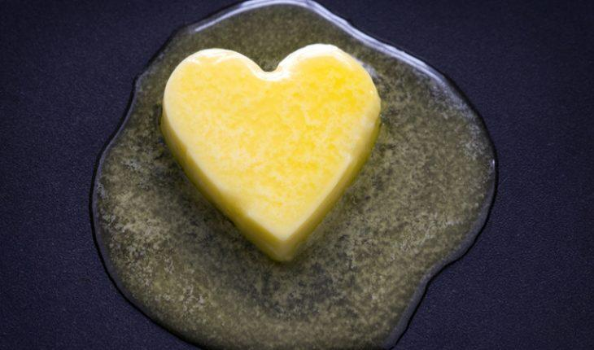

Unless you’ve been stuck in a time warp or hiding under a rock, you’ve heard the news surrounding a concept that completely runs in the face of those lies. The promise of lowering your body fat by lowering your nutritional fats has been scientifically disproved.
To put it simply ... fatty food doesn’t create fatty figures! Carbs and sugar do!

So, What’s the Skinny on Fat?
The main idea of the keto diet is to train your body to use dietary fats to burn body fat! Basically, you need to eat fat to burn fat.
On the keto diet, you eat 75% of your foods from fat, 20% from protein and 5% from carbs. This means that if you eat 1,200 calories in a day, you’d consume about 60 calories from carbs, 240 from protein and 840 from fat. Eliminating carbs from your diet, and adding healthy fats, forces your body to enter a state of ketosis, and that is when fat burning begins.

Ketosis is a metabolic process. When the body does not have enough glucose for energy, it burns stored fats instead. This results in a buildup of acids called ketones within the body.

Sadie learned why all those fad diets she’d tried in the past failed.
“I learned that it was because it’s easier for the body to burn carbs for energy, so when we try to lose weight by cutting calories alone, the body continues to burn the carbs we eat for energy and our body fat remains. The keto diet was built on the premise that if our body “learns” to use fat for a fuel source, instead of carbs, it will start to burn body fat. By starving the body of carbs, it begins to turn to body as its main fuel source.” Sadie explained.
“But, as great as it sounds in theory, it isn’t easy to stick to such a strict regimen.” She continued to explain. “Unless you stay in ketosis, the keto diet is useless. In fact, if you’re eating all those extra fats and not getting into the fat burning stage, you could even gain weight. Ketosis is KEY! But so many people, like me, struggle getting into ketosis.”
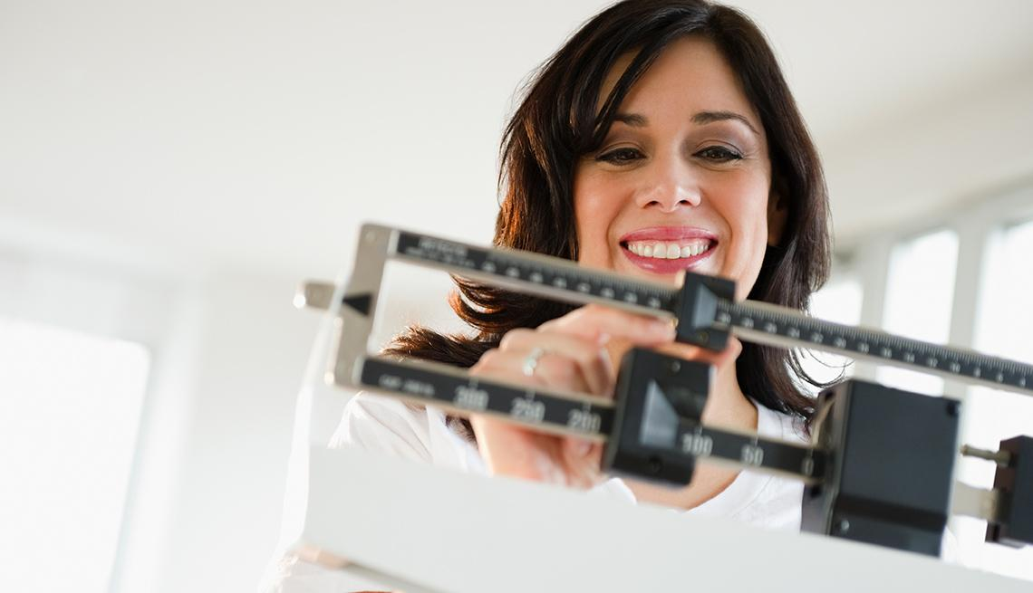
“Before Nature’s Pure Keto, I couldn’t get into ketosis and weight loss was too slow!””

Nature’s Pure Keto Kickstarts Ketosis Faster than Keto Alone!
Sadie started prepping, cooking and eating all the right foods to get into ketosis fast. She knew the faster she got into ketosis, the faster she’d start to burn fat and lose weight.
“After two weeks on keto, I lost a few pounds, but I never actually got into ketosis.” she explained with frustration. “I knew I needed to lose weight faster if I was going to save Sydney’s life!”
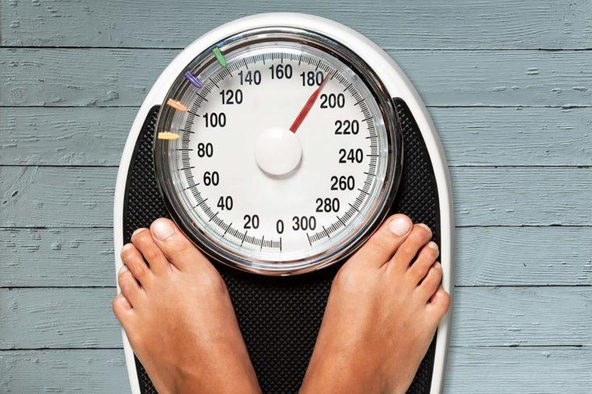
As a busy mom with two kids, all the meal prepping was hard to.
“Keto is great but I’m too busy, plus I needed it to work faster!” she cried.

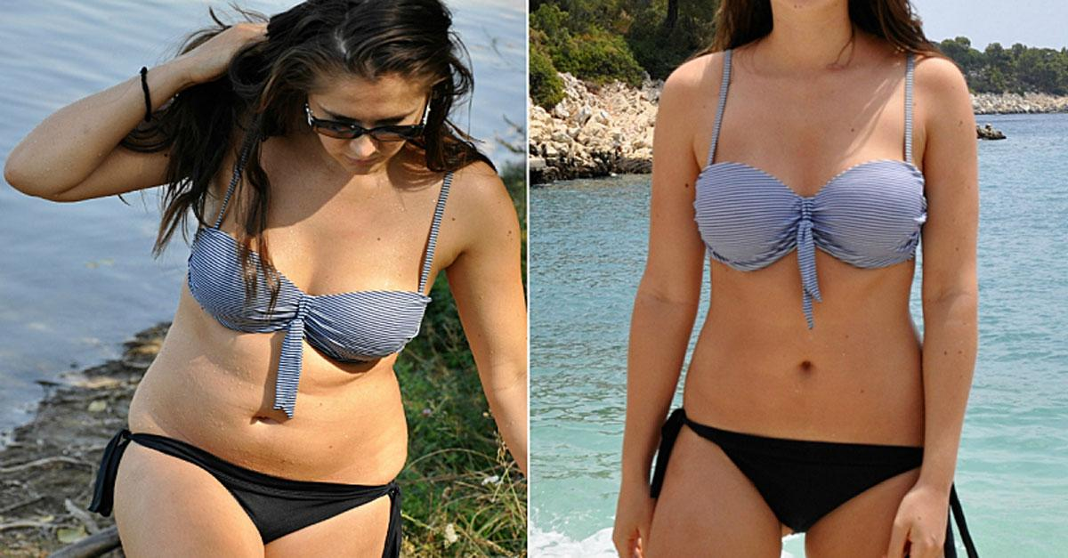
“Just when I was about to give up, a friend told me about a risk free trial offer for Nature’s Pure Keto.”

That’s when a friend told Sadie about a new weight loss supplement she had tried. She explained how it mimicked the keto diet by producing ketones but went on to tell her it works much faster than the keto diet alone. She told her that she got into ketosis in less than 30 days using the amazing new supplement, Nature’s Pure Keto. She told her she was burning fat and losing weight faster than ever since she started taking this supplement. To help her distraught friend, she sent Sadie a link to a site that offered a Free 30 Day Supply of Nature’s Best Keto.
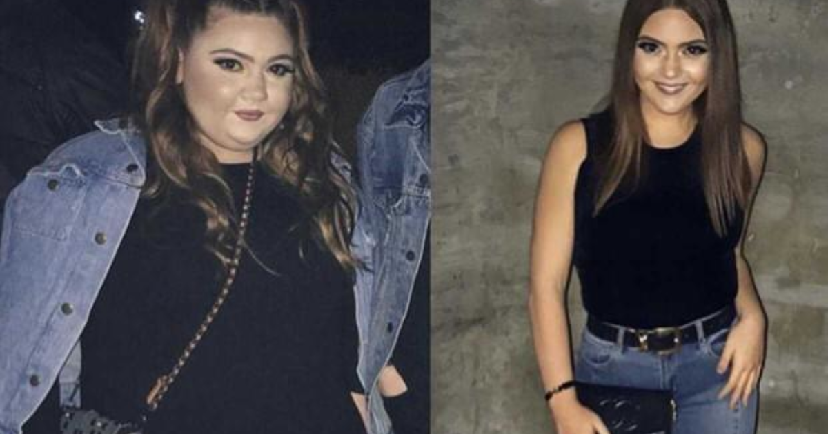
“I took a leap of faith right away and ordered my Free 30 Day Supply of Nature’s Best Keto. I lost 250 pounds and I’m at my lowest weight ever!”

What is Nature’s Pure Keto?
The doctors behind Nature’s Pure Keto have discovered a way to harness the power of the fat burning ketone, BHB, and modify it so that it forces the body to naturally enter the state of ketosis instantly! Nature’s Pure Keto is the fat burning solution we’ve all been waiting for!
Beta-hydroxybutyrate is the first supplement ever discovered that kicks the metabolic state of ketosis into action. The moment this modified ketone enters the bloodstream, it begins sending the process of ketosis into overdrive. The result is instantly increased energy and unbelievably quick weight loss. No more peeing on strips and waiting around for weeks for your body to enter ketosis. Nature’s Pure Keto is the first keto supplement on the market that allows you to skip the struggle of the keto diet and start burning fat immediately.

30-Day Ketosis is Possible!
“I was so excited to try Nature’s Pure Keto.” Sadie recalled. “I decided to take a leap of faith and place my order for the Free 30 Day Supply right away. I knew I had to do something fast to lose weight if I was going to save my sister’s life!
Two days later, Sadie received her Risk Free Trial Offer.

Sadie started to take the supplement the moment it arrived. In just one week, she noticed her tummy looked flatter. By week two, she got the courage to step on the scale.
“I couldn’t believe my eyes! In only 2 weeks, I lost 50 pounds!”
“Nature’s Pure Keto is the easiest way to burn fat!” she exclaimed. “It helped me burn fat faster than anything I’ve tried before!”

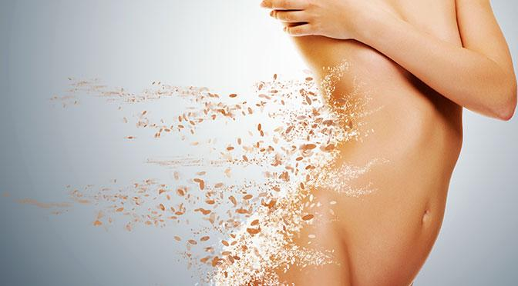

Lose up to One Pound a Day with Nature’s Pure Keto!
She continued taking Nature’s Pure Keto every day for the next month. To her extreme relief, she lost those nasty 100 pounds in less than 6 weeks. After two months, she was under 200 pounds, a weight she hadn’t seen on the scale in years. The transplant was on!!!
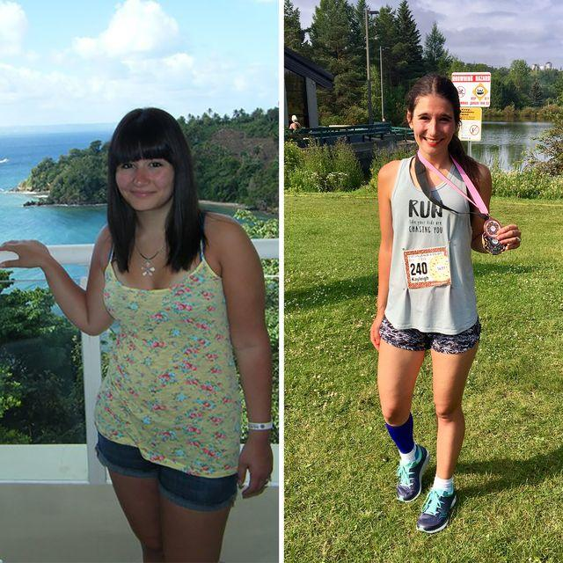
“I’m Half the Girl I Used to Be Thanks to Nature’s Pure Keto”

Thanks to Nature’s Pure Keto, Sadie was able to donate one of her kidneys to her sister.
I was there the day of the surgery and watched the girls hug before the operation. Sydney kissed her big sister and thanked her for saving her life.
The surgery was a success and today, Sydney is healthy and forever grateful to what her big sister did for her. Sadie, who continued to stay on her weight-loss journey, is now down to 150 pounds. She lost a total of 150 pounds using this miraculous new supplement!
“I lost weight and saved my sister’s life, thanks to Nature’s Pure Keto.”

“It’s pure and simple…
Nature’s Pure Keto is a Lifesaver!”


“Before Nature’s Pure Keto came into my life, I thought my obesity would kill my little sister. Now I’m healthier and thinner than ever, and my beautiful sister is healthy and back to enjoying her life.”

The Word is Getting Around!

“I lost 1 pound of fat every day since I started taking Nature’s Pure Keto. I haven’t looked or felt this good since high school!” – June B., Omaha, NE
“I gained over 150 pounds during lockdown. Then, I lost 200 pounds fast using Nature’s Pure Keto! This stuff works!” Joe B., Philadelphia, PA
“I lost 250 pounds in 4 months thanks to Nature’s Pure Keto.” – Jill T., NYC, NY
“I gained the dreaded Quarantine 15 during lockdown, but I lost 50 pounds using the amazing fat blaster!” – Jenny A., Palo Alto, CA

We Put it to the Test and Won!
When the staff at the paper, heard about Sadie and Sydney’s heartwarming success story, a bunch of them started a weight loss challenge of their own.
Even Joe, our editor -in-chief got involved and said he’d treat anyone who loses 20 pounds out for a healthy, but fancy dinner.
Ten staff members jumped at the chance to win the challenge. Each staff member who participated, including the me, lost OVER 20 pounds in the first 2 weeks!
“You’re all winners!” Joe said, “dinner is on me!”
Five of the staff members, who had more weight to lose, continued taking the supplement for an additional two months. Thanks to Nature’s Pure Keto, they lost a combined weight of 600 pounds!


“Thank you, Nature’s Pure Keto!”

Join the Thousands Who Are Already Losing up to One Pound Per Day!
Due to its enormous popularity and extremely high demand, supplies of Nature’s Pure Keto are becoming increasingly limited.
I urge you to check availability for your own Free 30 Day Supply of Nature’s Best Keto. before supplies are gone!

Exclusive Offer for Our Readers Only… Mention Sydney and Sadie’s inspirational story and receive a Free 30 Day Supply of Nature’s Pure Keto!

“I lost 150 pounds with
Nature’s Pure Keto!”
You Can Too! Click Here to Rush Your Free Trial!



Women everywhere are celebrating this revolutionary weight loss solution and the news is spreading fast! Nature’s Pure Keto uses the science behind the keto diet and harnesses its powerful benefits into an easy-t0-take daily supplement. Finally, people are seeing body fat melt away without the hassle of the keto diet.



Women Across America are Raving About Nature’s Pure Keto

“I lost 150 pounds since I discovered One Shot Keto. It works!” -Skye C., Cheltenham, PA

“I finally got into ketosis and I lost 200 pounds thanks to One Shot Keto!” -Lauren K., Amherst, MA

“One Shot Keto helped me 40 pounds in just 3 months and I never felt better!” – Ilene B. Newtown, PA

Shares Her Weight-Loss Secret & This Limited Time Offer!

