ADVERTORIAL
Golden State News – Lifestyle Magazine – May 12, 2021
Breaking News!
Happy Bride Drops the Weight to Tie the Knot
Amazing Keto Supplement Vows to Burn Fat Fast!

By Larissa Victor, Lifestyle Reporter, investigates a new fat-burning supplement that’s taking the internet by a storm.
Amanda Morrison grew up in a quaint beachside town in Northern California. Known for its cookie cutter cottages, pristine beaches and breathtaking sunsets, it was a family-oriented community with low crime rate and highly rated schools. Like a lot of little girls, Amanda grew up dreaming about the fairy tale wedding she would have some day. While her friends were practicing their cartwheels and back flips, Amanda was practicing tossing the bouquet.



Head cheerleader for the high school football team, senior class president and a straight A student, Amanda enjoyed all the perks of being a pretty and popular teenager. The happy young lady enjoyed growing up in her tiny beach hometown, but she had dreams of moving to the big city one day and right after graduation, she pulled up anchor and set sail to the east coast to attend college.
Amanda moved to New York City in 2010 and adapted quickly to life in the big apple. After graduating from the New York School of Design in 2015 with a degree in fashion merchandising, Amanda’s career started to take off. Her personal life started to flourish too when she met and started dating Nick, a native New Yorker from the Upper East Side.
Together, they indulged in the city’s art and culture scene and spent weekends exploring the great outdoors. At just 25 years of age, she was successful, happy and in the best shape of her life.



As the years passed, stressful, long days at work started to take a toll on her body. Without even noticing, she was exercising less and eating more. Inevitably, she began to put on weight and by her 30th birthday, she realized she had gained over 50 pounds since her high school glory days.
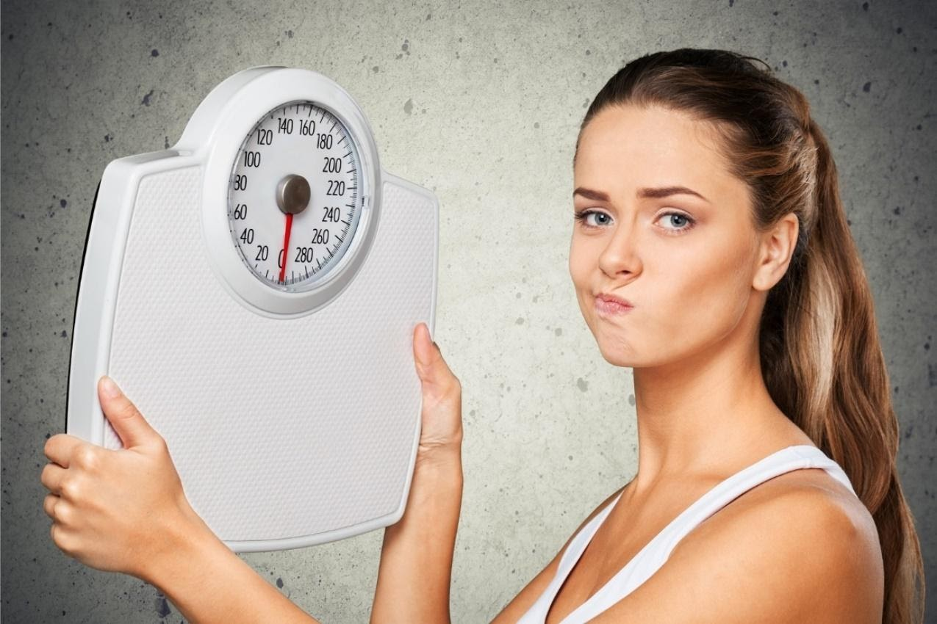
As a surprise 30th birthday gift, her college sweetheart proposed, and the pair began to make plans to marry on the beach in Amanda’s hometown the following June. She was thrilled and terrified at the same time. As excited as she was about having a June wedding, and being back home with her family and friends, all she could think about was her weight and that she had to lose 50 pounds by the big day.
“We’re both Jewish and at traditional Jewish wedding’s the bride and groom are lifted on chairs by the guests while dancing to a dance called the hora.” Amanda explained.
“All I could think of was how embarrassed I would be if I was too heavy to lift!”


“I was always the bridesmaid, never the bride until I lost 50 pounds using Nature’s Pure Keto.”

Then, one day, while browsing through gowns at a New York City bridal shop, she found what she thought would be her dream gown. But, as soon as she went to try it on, her dream turned into a nightmare.
“I was a size 6 all my life,” Amanda recalled. “but now, I was in my early thirties and the only dresses that would fit me were sizes 14-16. I always envisioned myself looking like a princess on my wedding day but when I tried on the gown of my dreams in a size 16 (that’s the only one I could squeeze into) I actually thought about eloping.”


“I thought about eloping before I discovered Nature’s Pure Keto.”

“I knew I had to lose 50 pounds, or my dream wedding was going to be more like a nightmare,” Amanda cried.
She knew she had to do something fast if she was to make this goal a reality. With less than 12 months to go until the big day, Amanda began searching for a solution.
First, she decided to try Weight Watchers.
“I went to my first meeting excited to get started. I heard they weighed you, and I was prepared for what the scale would say. But what I wasn’t prepared for was that the woman running the meeting would announce my weight to the entire room. I was so humiliated I almost crawled under my seat,” Amanda shared.
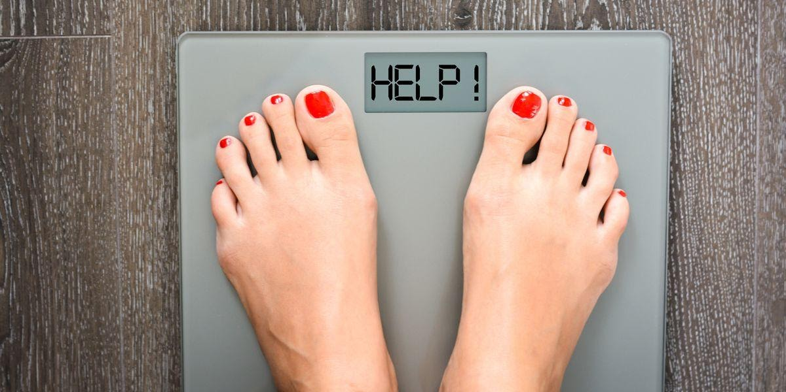
“The other women in the meeting were very kind, so I felt a little more at ease. And when I heard some of the success stories they shared, I was encouraged. But the diet was very time consuming.” She continued. “You have to count points and record every single thing you eat. I was very busy with my career and that was a lot of work. After the first week, I was happy when the meeting leader announced I had lost 7 pounds. But, in the weeks that followed, I only lost a total of 2 pounds. I think the first week was all water weight. After the third week of not losing an ounce, I gave up. Now, I only had 11 months until I’d be saying my vows. I had to do something fast!”

Not about to give up, she tried another popular diet, Jenny Craig.

“I liked this one a little more because you meet privately with a personal weight loss consultant, so it wasn’t quite as humiliating. But the meals were all pre-packaged and tasted awful.” She recalled. “They were really nothing more than expensive frozen dinners and I ended up actually gaining 5 pounds while on Jenny Craig because there was so much salt content in the meals that I blew up like a balloon. Not exactly the result I was looking for, to say the least. Now I had only 10 months to go. I was getting really scared that I wouldn’t lose the weight.”

I asked her if she was ready to give up after that experience, but she was still determined to find the right weight loss program. Next, she tried Atkins.
“I like Atkins a little more because it was free, number one, and there weren’t any meetings or time-consuming sessions at a center. But the food was terrible. I have never been a big meat eater, and that’s basically all you eat on that diet! So,” she remembered, “I gave up on that one really quick.”
With less than 10 months to go until the wedding, and still over 50 pounds to lose (she hadn’t lost an ounce, after all was said and done, on the three programs she tried), she was running low on time and patience.

Don’t Wait to Lose the Weight!
That’s when she heard a friend at work talking about how she lost 15 pounds on the keto diet in just one month and decided to give it a try.
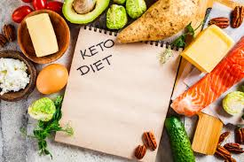

“I read about an article about the keto diet. I learned why the keto diet works and why all the fad diets I tried fail. If you’re like me, you’ve been brainwashed to believe that eating fats equaled being fat. The myth was that the fat we consumed would become the body fat we’d carry on our tummies and hips.” Amanda explained.
“The concept behind the keto diet runs in the face of all those lies. The promise of lowering your body fat by lowering your nutritional fats has been scientifically disproved.”



Fats are the New Skinny!
Amanda went on to explain about the science behind the keto diet.
“Keto trains your body to use dietary fats to reduce body fat. Basically, you need to eat fat to burn it. Eliminating carbs from your diet, and adding healthy fats, forces your body to enter a state of ketosis, and that is when fat burning begins.”
Amanda learned that because it’s easier for the body to burn carbs for energy, when we try to lose weight by cutting calories alone, the body continues to burn the carbs we eat for energy and our body fat remains. The keto diet was built on the premise that if our body “learns” to use fat for a fuel source, instead of carbs, it will start to burn body fat. By starving the body of carbs, it begins to turn to body as its main fuel source.

What is Ketosis?
Ketosis is a metabolic process. When the body does not have enough glucose for energy, it burns stored fats instead. This results in a buildup of acids called ketones within the body.

“I lost 10 pounds after one week on the keto diet and I was really excited.” She recalled. “I was finally seeing results for the first time and I decided to keep going. But the meal prep was very time consuming. And it was really hard to get into ketosis. To make matter worse, as hard as it was to get into ketosis, it’s even harder to stay in it. After a while, I stopped losing weight and I started to get really frustrated again.”

To help speed up her weight loss, Amanda started exercising again, along with her keto meal planning. It was a lot of work, but she knew it was necessary if her dream wedding was going to be a reality. But the results were slower than she had hoped. Once again, she almost gave up.



Just when she was about to give up on keto and her wedding plans, she came upon an article about a newly discovered fat burning supplement called Nature’s Pure Keto that mimics the keto diet. The article explained how taking this simple supplement accelerates keto’s fat burning process by providing additional ketones that kick-start ketosis. And the best part was, there was an offer for a FREE 30 Day supply!

Instant Ketosis
is Finally Possible!
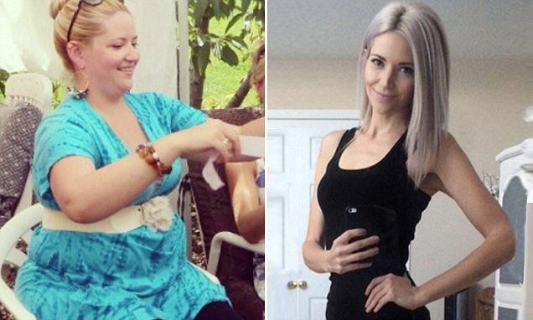
“I read an article about women getting astonishing results using Nature’s Pure Keto.”

What is Nature’s Pure Keto?

The great scientific minds behind Nature’s Pure Keto have discovered a way to harness the power of the fat burning ketone, BHB, and modify it so that it forces the body to naturally enter the state of ketosis instantly! Beta-hydroxybutyrate is the first supplement ever discovered that kicks the metabolic state of ketosis into action. The moment this modified ketone enters the bloodstream, it begins sending the process of ketosis into overdrive. The result is instantly increased energy and unbelievably quick weight loss. No more peeing on strips and waiting around for weeks for your body to enter ketosis. Nature’s Pure Keto is the first keto supplement on the market that allows you to skip the struggle of the keto diet and start burning fat immediately.

“Nature’s Pure Keto was the fat burning solution I’d been waiting for!” Amanda exclaimed. “I was so excited about the claims that this supplement helps you to lose up to one pound a day that I decided to take a leap of faith and place my order for the Free 30 Day Supply right away. I knew I had to do something fast to lose weight if I was going to have my dream wedding day! Two days later, I received my Risk Free Trial.”
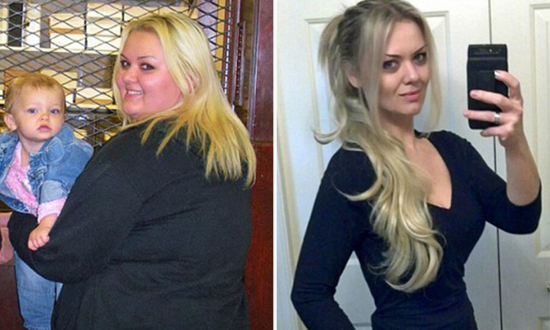

What Makes Nature’s Pure Keto So Effective?
The natural ingredients work together to get the body into an accelerated fat-burning state. Some stimulate the cells to release fat for energy, while others prevent carbohydrates from being stored in cells as fat. Some even increase the body’s ability to absorb nutrients from food – which is why people often report that they feel so great when taking Nature’s Pure Keto.


Amanda went on to explain more. “Nature’s Pure Keto provides exactly what’s needed to boost any weight-loss attempts. If you want, you can use it on its own, or in conjunction with the keto diet. It works because it causes the body to switch to using fat, rather than glucose (carbohydrates), as its primary energy source. And because they’ve incorporated natural exogenous ketones, the excess weight seems to melt away as if by magic. But it’s not magic, it’s science!”
Watch Weight Loss Take Off Fast with Nature’s Pure Keto!


How Does it Work?

Nature’s Pure Keto works by incorporating an ingredient called BHB (Beta-Hydroxybutyrate), into its formula. This key ingredient is a ketone that allows the body to adjust faster to burning body fat stores for energy. It “teaches” the body to start using ketones for energy instead of carbs. Side effects of a low carb diet such as a feeling of lethargy, weakness and mental fog, are eliminated because BHB works to increase energy levels. Instead of feeling drained from a lack of carbs, you’ll feel more energetic and ready to take on the world!

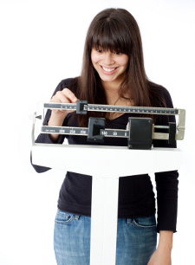

Amanda continued to take her Nature’s Pure Keto supplements every day and stick to the keto diet. She quickly got back into ketosis and the results started to show on the scale immediately! After just two weeks, she started to see the pounds fall off!
By the second month, Amanda’s weight loss really started to take off! She began to feel so confident that she started shopping for wedding dresses again. Over the next two months, she continued to take the Nature’s Pure Keto supplements every day.



Just four months after beginning her weight loss journey, with the help of Nature’s Pure Keto, Amanda reached her weight loss goal of losing 50 pounds, and found the perfect wedding dress… in a size 6!


“I lost 50 pounds using Nature’s Pure Keto… just in time for my dream wedding!”
Amanda went ahead with her plans for a June wedding. Feeling better than she had in years, she couldn’t wait to go back home to California and say her vows in front of all her friends and family. Instead of running away and eloping, Amanda practically ran down the aisle, feeling confident and beautiful.
“I danced the hora with my family and friends and when it was time to be lifted up on the chair, I felt lighter than air!” she said with excitement in her voice.
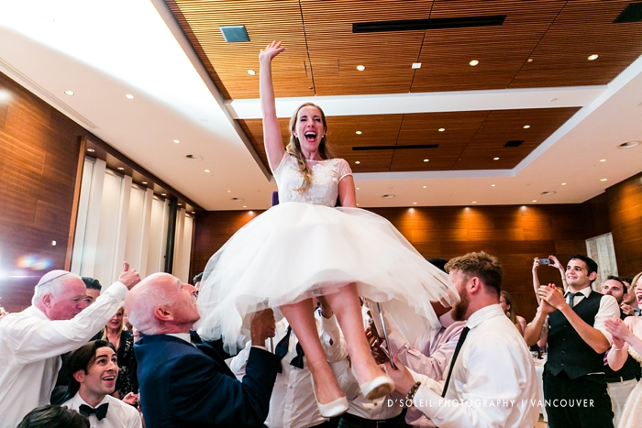
Nature’s Pure Keto Gives Ketosis a Big Lift!

DON’T WAIT to LOSE the WEIGHT!

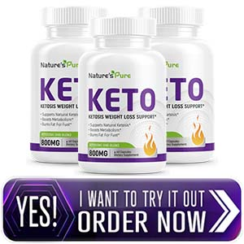

Women everywhere are saying “I do” to this revolutionary weight loss solution and the news is spreading fast! Nature’s Pure Keto uses the science behind the keto diet and harnesses its powerful benefits into an easy-t0-take daily supplement. Finally, people are seeing their body fat melt away without the hassle of the keto diet.



Women Everywhere are Tossing Failed Fad Diets Thanks to
Nature’s Pure Keto!

“I lost 50 pounds since I discovered Nature’s Pure Keto. It works!” -Shyanne C., Cheltenham, PA

“I finally got into ketosis and I lost 20 pounds thanks to Nature’s Pure Keto!” -Lauren H., Hollywood, CA

“Nature’s Keto made the keto diet work for me. I lost 40 pounds and I never felt better!” – Irena A. Philadelphia, PA

“I got my Happily-Ever-After thanks to
Nature’s Pure Keto”


Amanda wants to share her success with women everywhere. Mention Amanda’s Inspirational Love Story with Weight-loss and Receive a
FREE 30 Day Supply of Nature’s Pure Keto!

Join the Thousands Who Are Already Losing up to
One Pound Per Day!
Due to its enormous popularity and extremely high demand, supplies of Nature’s Pure Keto are becoming increasingly limited.
I urge you to check availability for your own Free 30 Day Supply of Nature’s Best Keto. before supplies are gone!
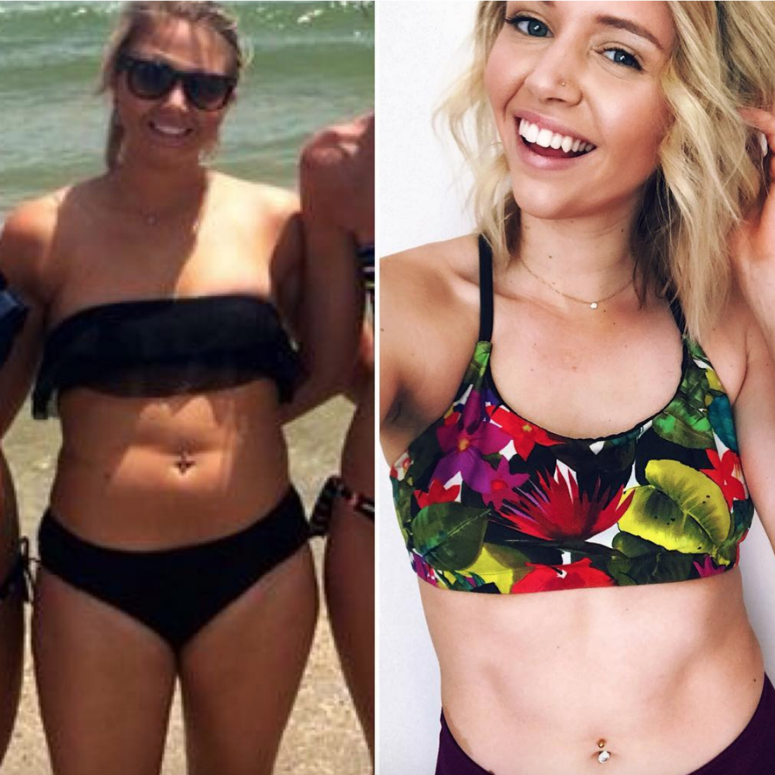
Exclusive Offer for Golden State News Readers Only… Mention Amanda’s inspirational story and receive a Free 30 Day Supply of Nature’s Pure Keto!

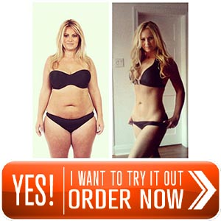

VOW to Look Your
Beach-Body-Best this Summer with
Nature’s Pure Keto
Summer is just around the corner, so there’s no time to waste! Stop spending time and money on failed fad diets and join the thousands of women just like you that have lost up to one pound a day with this miracle fat-burning supplement.
“Rush me my Free 30 Day Supply of Nature’s Pure Keto.”


Get Your Free 30 Day Supply of Nature’s Pure Keto today!


And… They lived happily-ever-after!

