ADVERTORIAL
Philly Health & Fitness Magazine – March 10, 2021

It was Do or Her Mom Could Die
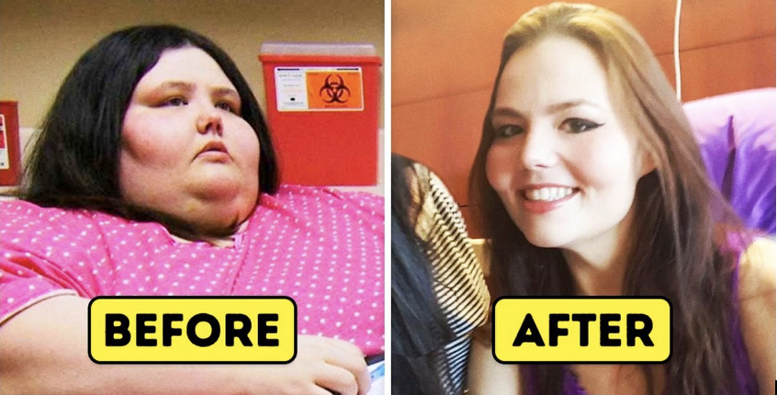
Morbidly Obese Daughter Loses Weight to Save Her Mom from Covid-Ravaged Nursing Home
By Eileen Honey Strauss

“I Got Lean During Covid-19!”
It was April 25, 2020 when I first met Kourtney James, a 32 year-old woman who had recently learned that the nursing home where her mother had been staying for the past two years, was being ravaged by Covid-19. Cases and deaths among the staff and the residents were skyrocketing. Kourtney had not been able to see her mom for almost two months at that point, ever since they stopped allowing visitors. Like many others in lockdown, Kourtney, who had struggled with her weight for years, found herself using food more than ever to cope with the stress of the pandemic.
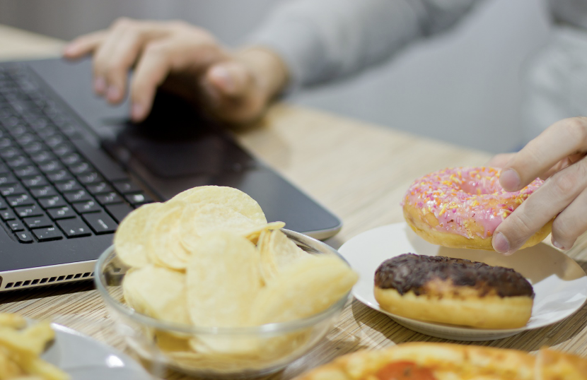
“My office closed in early March,” Kourtney recalled. “I was working from home and I never left the house. I started using food as a coping mechanism to help me get through the lonely days.”

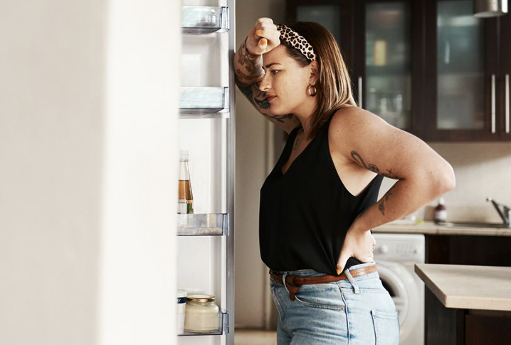

During lockdown, Kourtney had all her food and necessities delivered. Like the rest of the country, she was scared to go anywhere, and there weren’t many places to go. Kourtney started ordering a lot of snack foods, including ice cream, candy, chips and dip, frozen pizza and cake. Healthy food was hard to come by (or at least that was her excuse), so she ate a ton of carb-packed foods like pasta and macaroni and cheese. As the days went by and time ticked on, she spent her days sitting on the couch binging Netflix or at her desk on zoom meetings, getting little to no exercise.
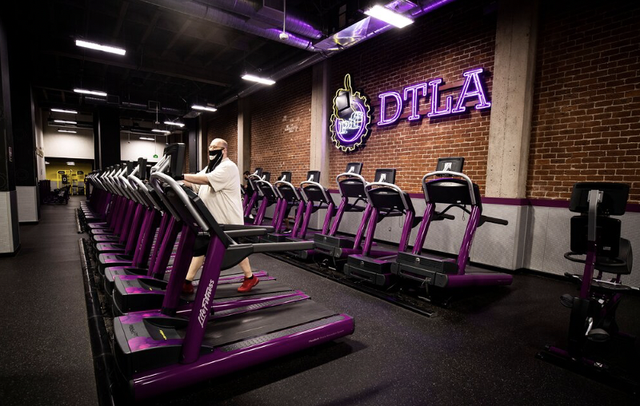
As a journalist specializing in the health field, I was paying close attention to the way people were reacting to this new normal. Soon after the pandemic started, it was becoming clear that, for many people, isolation, boredom and the fact that gyms were closed, could inevitably lead to weight gain. Many Americans started joking about the dreaded “quarantine 15,” worried that being shut in at home with stockpiles of food, glued to computer screens and binge-watching tv shows could lead to weight gain.
Because most people don’t announce their weight to the world, it was difficult to assess the extent of the problem. With most medical visits being done virtually, there wasn’t much empirical evidence to go by. Recently, however, with things opening up, it has become clear that the quarantine-15 was a generous underestimation. The fact is the average American put on a lot more than that. Bluetooth- connected smart scales and weight-loss apps, began to reveal that that more than 50% of Americans studied put on 1 pound every 10 days, or 3 pounds a month, during the pandemic. That amounts to 36 pounds in one year. Studies show that more than 25% of quarantined Americans gained 50 pounds or more and 10% gained 100 pounds or more.

Kourtney was falling into the top ten category. After the first two months, Kourtney packed on 85 pounds. Already tipping the scales at well over 350 pounds before Covid (the max her home scale measured), Kourtney had no way to even know how much she had gained. But the truth was, she didn’t really need a scale to tell her.
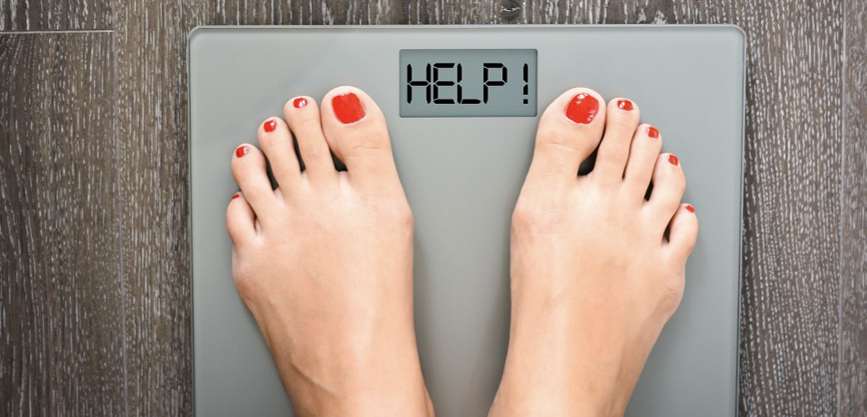
“I could tell by the way my clothes fit (didn’t fit) I was over 400 pounds. I couldn’t even walk upstairs to my bedroom anymore.” She recalled. “I barely even bathed. But I was working from home, and not seeing anyone, so I figured it didn’t matter anyway.”
Kourtney tried to justify her weight gain to herself.
“I figured, so what if I gain a little more weight. I’m not hurting anyone!”
But, suddenly, that was not true. That’s when her real nightmare began. Kourtney got a call from the head nurse at her mom’s nursing home revealing that the positivity rates among staff and residents was now at 75%. Before that, they didn’t have testing available, so they really didn’t know who had Covid and who didn’t. The nurse also revealed to Kourtney, with the sound of obvious fear and sadness in her voice, that they had lost 10 residents that week, and 15 were in the ICU on ventilators.
“My mom was all alone and could die because of me!” Kourtney cried. “I needed help fast!”
Kourtney’s mom, having been isolated in her private room for two months, with no human contact other that the med check visits from the staff (who were dressed from head to toe in PPE and couldn’t really speak to her) tested negative. But the nurse warned Kourtney that the probability of her mom contracting the deadly virus was close to imminent. She warned her that if she didn’t leave the nursing home soon, she could die.
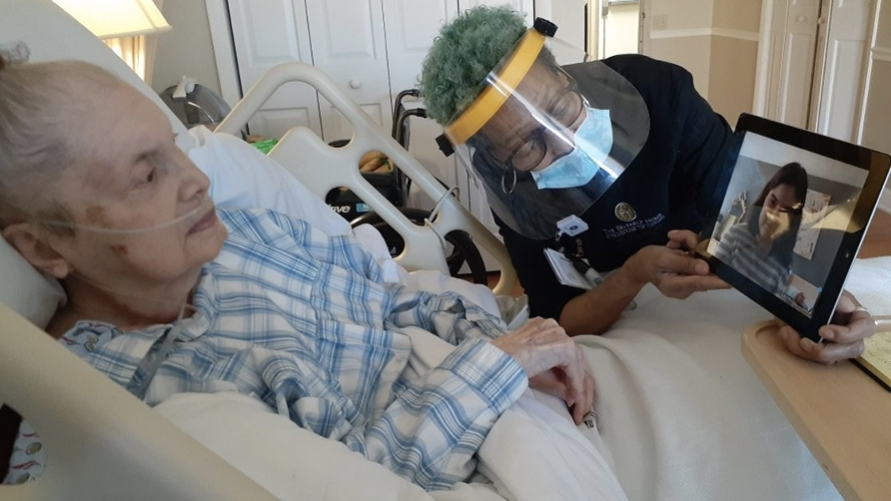
“I started to cry hysterically when I heard this news.” Kourtney remembered, “Because I knew I was in no shape to take care of my ailing mother.
Kourtney’s mom, who suffered a stroke three years prior, had to be placed in a home when Kourtney’s father died two years ago from an unexpected and sudden illness.
Kourtney knew then that she couldn’t handle taking care of her mom at her home, not only because she worked every day and was rarely home, but her mom required round the clock care and physical therapy and needed constant attention to her hygienic needs. It was a lot more medical attention and therapy than home care would allow.
At the time, a rehabilitation center (the kind word for nursing home) was the only option. But now, with Covid-19 spreading swiftly throughout nursing homes in America, things were much different.
“My weight was going to kill my mom!” she cried. “I had to do something fast!”
Kourtney knew if she was going to save her mom’s life, and get her out of the home, she’d have to lose weight. There was no time to lose!
“The nursing home was becoming a waiting room for death” she exclaimed. “I knew my mom would be dead soon if I didn’t do something.”
The first thing Kourtney did was go through all her cabinets and the fridge and throw away all the junk food she had. Because there weren’t a lot of stores open to shop, she ordered meals from one of those weight loss companies that send frozen meals.
“The food was disgusting! It was like the meals astronauts must eat in space.” She halfway giggled.
That’s when Kourtney read about an article about the keto diet, and she decided to learn all she could and get started right away.
“I learned how the keto diet worked and bought all the right foods so I could get started.” she shared.

Why Keto Works
If you grew up in the ’60s, ’70s or ’80s, your brain was washed to believe that eating fats equaled being fat. The myth was that the fat we consumed would become the body fat we’d carry on our tummies and hips. Thus, the “miracle reduced-fat diet” food fad was born.
Low-fat, skim and nonfat were the buzz words of the day and foods like yogurt, milk, cheese, mayonnaise, snack foods and salad dressing with these false promises began to line the shelves. Labels promising weight loss due to fat reduction became the industry norm, and we, the consumer, bought it like hotcakes. (Low-fat ones, of course.)
But today, the myth behind the “miracle” has been dispelled.

Unless you’ve been stuck in a time warp or hiding under a rock, you’ve heard the news surrounding a concept that completely runs in the face of those lies. The promise of lowering your body fat by lowering your nutritional fats has been scientifically disproved.
To put it simply ... fatty food doesn’t create fatty figures! Carbs and sugar do!

Fats are the New Skinny!
The main idea of the keto diet is to train your body to use dietary fats to reduce body fat! Basically, you need to eat fat to burn it.
On the keto diet, you eat 75% of your foods from fat, 20% from protein and 5% from carbs. This means that if you eat 1,200 calories in a day, you’d consume about 60 calories from carbs, 240 from protein and 840 from fat. Eliminating carbs from your diet, and adding healthy fats, forces your body to enter a state of ketosis, and that is when fat burning begins.
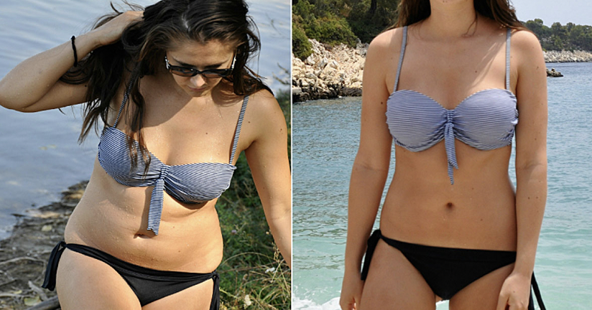
“Before Nature’s Pure Keto, I couldn’t get into ketosis and weight loss was too slow!””

Ketosis is a metabolic process. When the body does not have enough glucose for energy, it burns stored fats instead. This results in a buildup of acids called ketones within the body.

Kourtney learned why most of the diets she’d tried in the past failed. It’s because it’s easier for the body to burn carbs for energy, so when we try to lose weight by cutting calories alone, the body continues to burn the carbs we eat for energy and our body fat remains. The keto diet was built on the premise that if our body “learns” to use fat for a fuel source, instead of carbs, it will start to burn body fat. By starving the body of carbs, it begins to turn to body as its main fuel source.
As great as in sounds, it isn’t easy to stick to such a strict regimen, even during normal times. During the uncertain times we’re in, it can be even harder. Unless you stay in ketosis, the keto diet is useless. In fact, if you’re eating all those extra fats and not getting into the fat burning stage, you could even gain weight. Ketosis is KEY! But so many people struggle getting into, and/or staying in ketosis?

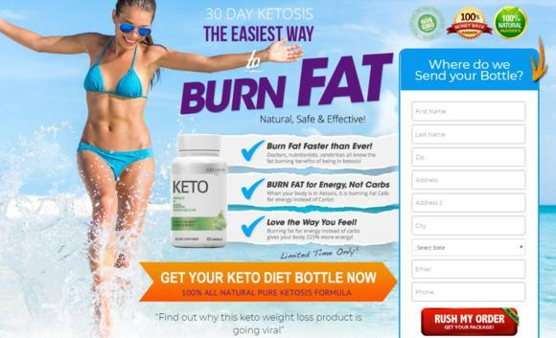

Nature’s Pure Keto Kickstarts Ketosis Faster than Keto Alone!

Kourtney started prepping, cooking and eating all the right foods to get into ketosis fast. She knew the faster she got into ketosis, the faster she’d start to burn fat and lose weight.
“After two weeks on keto, I lost a few pounds, but I never actually got into ketosis.” Kourtney explained with frustration. “I knew I needed to lose weight faster if I was going to get my mom home and save her life!”

“Just when I was about to give up, a friend told me about a risk free trial offer for Nature’s Pure Keto.”

That’s when June, a friend from Kourtney’s office admitted that she had also been gaining weight during quarantine and told her about a new weight loss supplement she had tried. She explained how it mimicked the keto diet by producing ketones but went on to tell her it works much faster than the keto diet alone. June told Kourtney that she got into ketosis in less than 30 days using the amazing new supplement, Nature’s Pure Keto. She told her she was burning fat and losing weight faster than ever since she started taking this supplement. To help her with distraught friend, June sent Kourtney a link to a site that offered a Free 30 Day Supply of Nature’s Best Keto.
“I took a leap of faith right away and ordered my Free 30 Day Supply of Nature’s Best Keto. I lost 250 pounds and I’m at my lowest weight ever!”

Get Lean and Mean During Covid-19 with Nature’s Pure Keto!


What is Nature’s Pure Keto?
The great scientific minds behind Nature’s Pure Keto have discovered a way to harness the power of the fat burning ketone, BHB, and modify it so that it forces the body to naturally enter the state of ketosis instantly! Nature’s Pure Keto is the fat burning solution we’ve all been waiting for!

A Natural Solution to Instant Fat Burning is Here!
Beta-hydroxybutyrate is the first supplement ever discovered that kicks the metabolic state of ketosis into action. The moment this modified ketone enters the bloodstream, it begins sending the process of ketosis into overdrive. The result is instantly increased energy and unbelievably quick weight loss. No more peeing on strips and waiting around for weeks for your body to enter ketosis. Nature’s Pure Keto is the first keto supplement on the market that allows you to skip the struggle of the keto diet and start burning fat immediately.

30-Day Ketosis is Finally Possible!
“I was so excited to try Nature’s Pure Keto.” Kourtney recalled. “I decided to take a leap of faith and place my order for the Free 30 Day Supply right away. I knew I had to do something fast to lose weight if I was going to save my mom’s life!
Two days later, Kourtney received her Risk Free Trial Offer.

Kourtney started to take the supplement the moment it arrived. In just one week, she noticed her legs were less swollen. She was able to walk up the stairs to her bedroom for the first time in months. By week two, she got the courage to step on the scale.
“I couldn’t believe my eyes! In only 2 weeks, I lost 75 pounds!”
“Nature’s Pure Keto is the easiest way to burn fat!” she exclaimed. “It helped me burn fat faster than anything I’ve tried before!”

Instant Ketosis is Finally Possible with Nature’s Pure Keto!
She continued taking Nature’s Pure Keto every day for the next month. To her extreme relief, she lost 150 pounds in less than 6 weeks. After two months, she was under 200 pounds, a weight she hadn’t seen on the scale in years.

“I love the way I look, and I love the way I feel!”
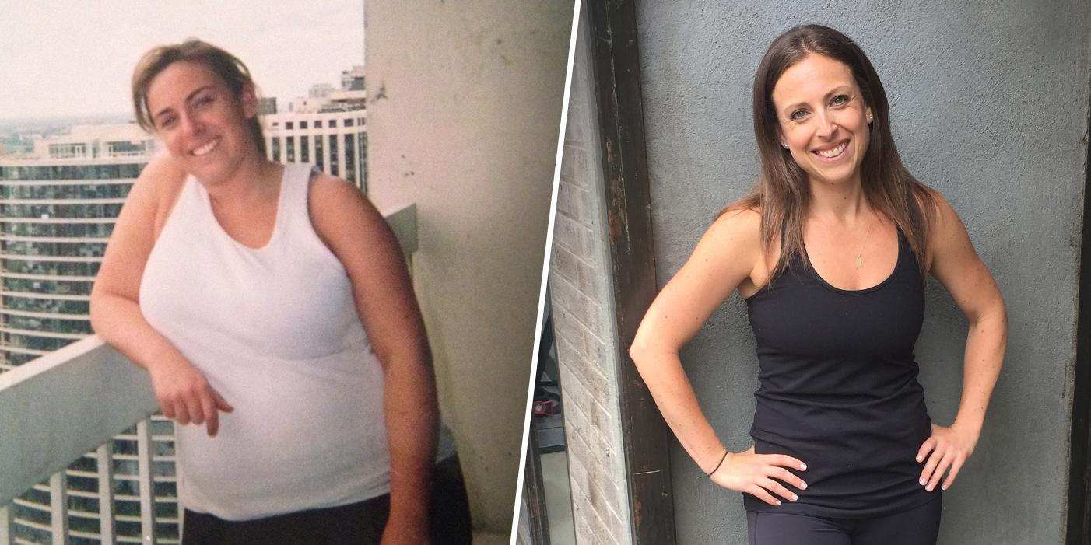
Thanks to Nature’s Pure Keto, Kourtney was finally able to take her mom out of the Covid ravaged nursing home and rescue her from the dangers of the virus.
I was there the day Kourtney and her mom, Katie, left the nursing home. Today, the pair is healthy and happy living together, continuing to ride out the storm of the pandemic. Kourtney, who continued to stay on her weight-loss journey, is now down to 150 pounds. She lost a whopping 250 pounds using this miraculous new supplement!
“I lost weight and saved my mom’s life, thanks to Nature’s Pure Keto.”


Nature’s Pure Keto is a Lifesaver!

“Before Nature’s Pure Keto came into my life, I thought my obesity would kill my mom --- and me. Now I’m healthier and thinner than ever, and my mom is safe at home with me.”

Media Frenzy Surrounds Nature’s Pure Keto Success Stories!
“I lost 1 pound of fat every day since I started taking Nature’s Pure Keto.” – June B., Omaha, NE
“I gained over 150 pounds during lockdown. Then I lost 200 pounds fast using Nature’s Pure Keto!” Betsy B., Brooklyn, NY
“I beat the dreaded quarantine 15 thanks to Nature’s Pure Keto.” – Bill T., NYC, NY



We Put it to the Test and Won!
When the staff at my magazine, Philly Health & Fitness, heard about Kourtney’s heartwarming success story, a bunch of them started a quarantine-15 weight loss challenge of their own.
The magazine’s publisher, who also put on weight during lockdown, decided to get it on the act too. To thank the staff for their hard work reporting throughout the pandemic, she decided to turn it into a contest. She announced over a zoom meeting, “Whoever loses their quarantine 15 first, wins a day off with pay!”
Ten staff members jumped at the chance to win the challenge. To the publisher’s shock, she was giving day’s off with pay to everyone! Each staff member who hanks participated, including the publisher, lost OVER 15 pounds in the first 2 weeks! Five of the staff members, who had more weight to lose, continued taking the supplement for an additional two months. Thanks to Nature’s Pure Keto, they lost a combined weight of 600 pounds!

Click Here to Rush Your Free Trial!



Revolutionary Fat Burning Supplement Makes a Huge Splash on Social Media!
The news of this miracle weight loss supplement is spreading fast! With the world beginning to open again, and people getting ready to trade in their loose-fitting lockdown sweats for feel-good-again fashion, weight loss has become the number one-most-searched topic on social media.

Join the Thousands Who Are Already Losing up to One Pound Per Day!
Due to its enormous popularity and extremely high demand, supplies of Nature’s Pure Keto are becoming increasingly limited.
I urge you to check availability for your own Free 30 Day Supply of Nature’s Best Keto. before supplies are gone!
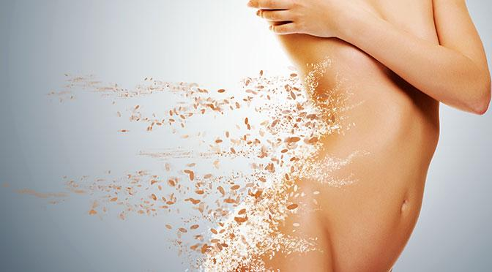

Exclusive Offer for Philly Health & Fitness Readers Only… Mention Kourtney’s inspirational story and receive a Free 30 Day Supply of Nature’s Pure Keto!

